**AWS Task-4**

**Task Description:**

Launch an EC2 instance (Linux and Windows) along with a web server. Then, create an EBS volume of 5 GB, attach it to an EC2 machine (Linux and Windows), and take a snapshot. Finally, create an EBS volume using the taken snapshot.

**Techstacks needs to be used :**

* AWS EBS
* AWS EC2

**Launch an EC2 instance (Linux and Windows) along with a web server:-**

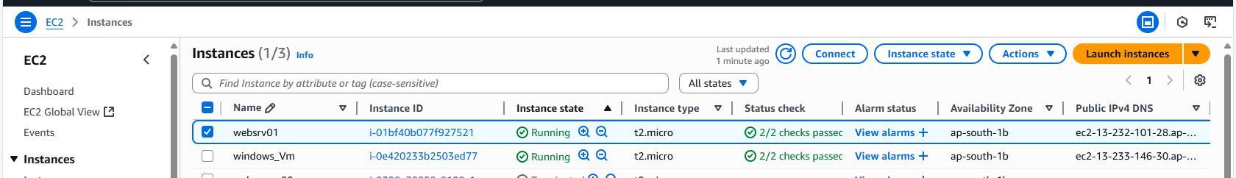

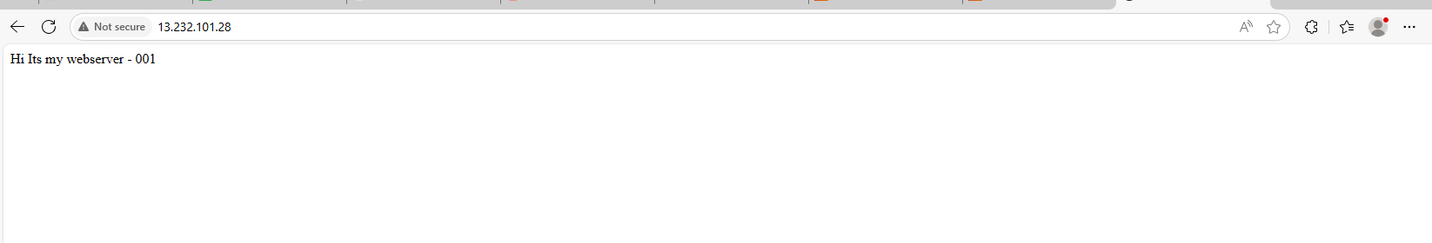

**EBS volume of 5 GB, attach it to an EC2 machine: -**

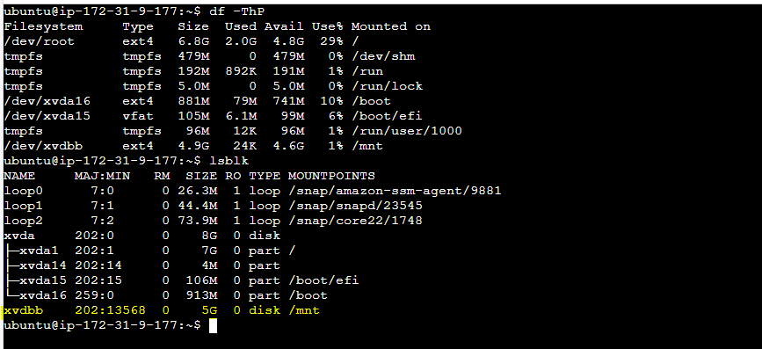  
  
  
  
  
**Windows_VM**

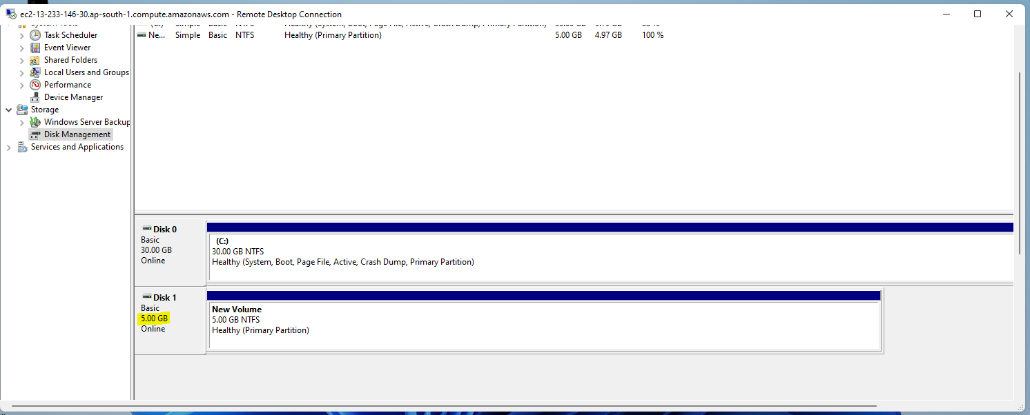  
  
  
  
**Snapshot: -**

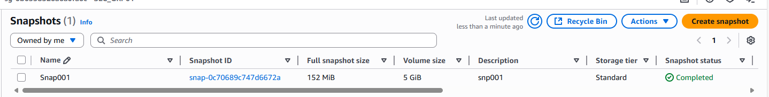

**Creating EBS Volume from snapshot: -**

